Programming:

* Keaton Miller: code inspiration for how to work ini files
* Various Gamemaker tutorials
* Nocturne <https://forum.gamemaker.io/index.php?threads/tracking-mouse-movement-speed-direction.47960/>

Art:

* Axe- Veeru5656 <https://opengameart.org/content/axe-4>
* Wrench-Santoniche <https://opengameart.org/content/wrench-0>
* Tree- b_o <https://opengameart.org/content/pine-tree-tiles>
* Fireball- reivaxcorp <https://opengameart.org/content/fire-explode>
* Fire logo - bart <https://opengameart.org/content/pixel-art-flame-icon>
* Fire Animation - ColorOptimist <https://opengameart.org/content/2d-pixel-fire-sprite-strip>
* Bunny - felinoid <https://opengameart.org/content/bunny-sprite>
* Grass - athile <https://opengameart.org/content/seamless-grass-texture-ii>
* Drone (concept) - NetSysFire <https://opengameart.org/content/futuristic-drone>
* Wood- Arthur <https://opengameart.org/content/wood-pile>
* Player (body)- Sogomn <https://opengameart.org/content/animated-character>

Sound:

* Melee - remaxim <https://opengameart.org/content/3-melee-sounds>
* Fire crackling - PagDev <https://opengameart.org/content/fireplace-sound-loop>
* Catching Fire - themightyglider <https://opengameart.org/content/catching-fire>
* Music - Alexander Zhelanov <https://www.youtube.com/c/AlexandrZhelanovsMusic>
* Rabbit Death - Dreams and Music <https://www.youtube.com/watch?v=TAvDp75sk30>
* Player damage - zander games <https://opengameart.org/content/damage-taken>
* Explosion- TinyWorlds <https://opengameart.org/content/explosion-0>
* Step, Wood pickup, Ash pickup - leohpaz <https://opengameart.org/content/12-player-movement-sfx>
* Chaching from Pixabay <https://pixabay.com/sound-effects/search/ching/>
* Button fail sound- Third Octave <https://soundcloud.com/third-octave>
* Wind- IgnasD <https://opengameart.org/content/wind>
* Birds chirp - isaiah658 <https://opengameart.org/content/ambient-bird-sounds>
* Tree fall - kurt <https://opengameart.org/content/chopping-tree>
* Rustle- qubodub <https://opengameart.org/content/20-rustles-dry-leaves>
* Flamethrower- qubodub <https://opengameart.org/content/fire-loop>
* Click- qubodub <https://opengameart.org/content/click>

Solution:

Starting position should look like this

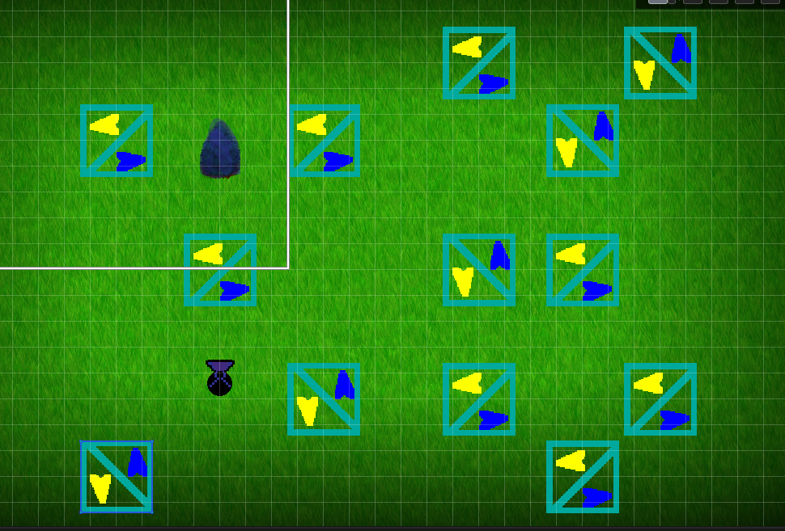

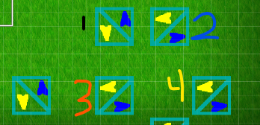

Before ball has hit # 4 but after ball has hit 1, 2, and 3, you need to rotate 1 2 and 3 to reflect the ball down.